Name: Dibya Jyoti Dhar
Assignment 4
Q1: JavaScript Coding Practice
- Check whether a number is even or odd.
Output
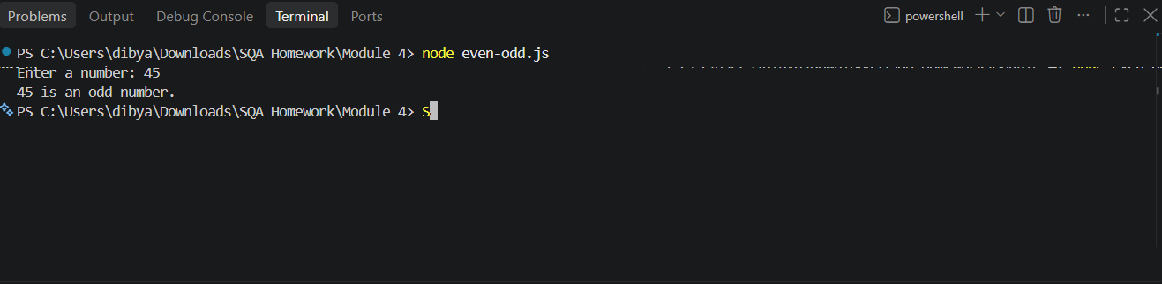
Explanation
This program takes a number from the user and checks whether it is even or odd. The readline module is used to receive input from the terminal. The % operator finds the remainder when the number is divided by 2. If the remainder is 0, the number is even; otherwise, it is odd. rl.close() closes the input interface after the program finishes.
- Find the largest of three numbers.
Output
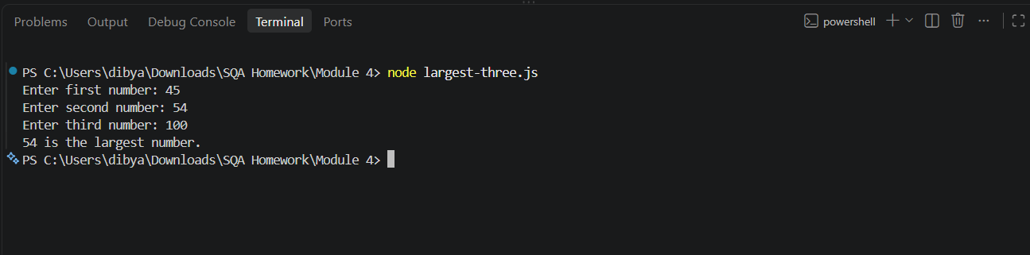
Explanation
This program takes three numbers as input from the user and compares them to find the largest one. The if...else if...else statements compare each number with the other two using >= and &&. The largest number is then displayed using console.log(). Finally, rl.close() closes the input interface.

- Reverse a string.
Output
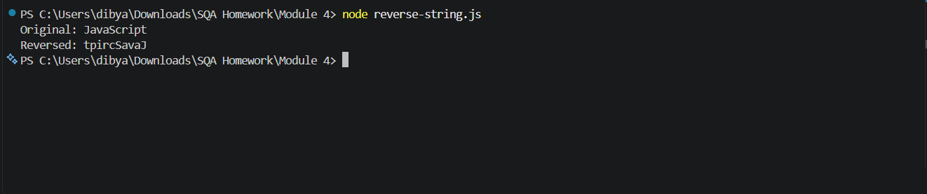
Explanation
This program reverses the string "JavaScript". First, split("") converts the string into an array of individual characters. Then, reverse() reverses the array, and join("") combines the characters back into a string. Finally, console.log() displays the original and reversed strings.
- Count vowels in a string.
Output
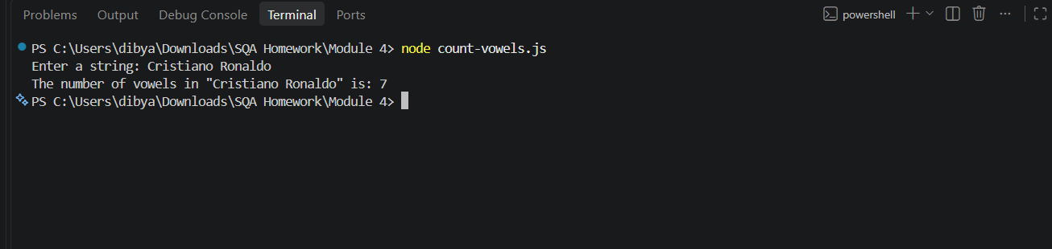
Explanation
This program takes a string as input and counts how many vowels it contains. The for...of loop checks each character in the string. The includes() method checks whether the character is a vowel (a, e, i, o, u) in either uppercase or lowercase. Each time a vowel is found, vowelsCount is increased by 1. Finally, the total number of vowels is displayed, and rl.close() closes the input interface.

- Remove duplicate values from an array.
Output
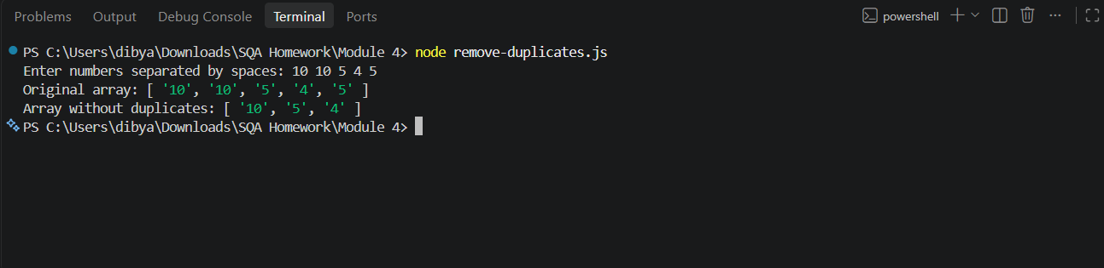
Explanation
This program takes numbers as input, separates them into an array using split(' '), and removes duplicate values using Set. The spread operator ... converts the Set back into an array. Finally, it displays both the original array and the array without duplicates. rl.close() closes the input interface.
Q2. Introduction to Node.js
1. What is Node.js?
Node.js is a runtime environment that allows JavaScript to run outside a web browser. It is built on Google's V8 JavaScript engine.
Normally, JavaScript runs inside browsers such as Chrome or Edge and is mainly used for web page interaction. With Node.js, JavaScript can also be used for backend development, automation, API testing, file handling, and command-line applications.
2. How Does Node.js Work?
Node.js uses an event-driven and non-blocking architecture. It uses an event loop to handle multiple operations efficiently.
For example, when Node.js needs to perform an operation such as reading a file or making a network request, it can continue working on other tasks instead of waiting for that operation to finish.
For example:
console.log("Start");
setTimeout(() => {
console.log("Task completed");
}, 2000);
console.log("End");
Output:
Start
End
Task completed
The program doesn't stop completely while waiting for the timer. Node.js continues executing other code and handles the completed task later.
3. Advantages of Node.js for QA Automation
Node.js is very useful for QA automation because many popular testing tools use the Node.js ecosystem.
Major advantages:
i. Web Automation: Node.js supports popular automation frameworks such as Cypress, Playwright, and WebdriverIO.
ii. API Testing: QA engineers can use Node.js libraries and frameworks to send API requests and verify:
- Status codes
- Response data
- Headers
- Response time
iii. Fast and Efficient: Its asynchronous and event-driven architecture is useful for handling multiple automation operations efficiently.
iv. Easy CI/CD Integration: Node.js-based tests can easily be integrated with tools such as Jenkins, GitHub Actions, and GitLab CI/CD.
v. Large npm Ecosystem: Node.js comes with npm (Node Package Manager), which provides thousands of packages for testing, automation, reporting, API testing, and other QA activities.
vi. JavaScript/TypeScript Support: QA engineers can use JavaScript or TypeScript to write automated tests, making it easier to work with modern web applications.

4. Difference Between Browser JavaScript and Node.js
Feature | Browser JavaScript | Node.js
Where it runs | Web browser | Computer/server
Main purpose | Web page interaction | Backend, automation, scripts
DOM access | Yes | No, by default
window object | Available | Not available
File system access | Restricted | Available
Database access | Usually through APIs | Can use database libraries
npm packages | Not directly | Yes
HTTP server | Not normally | Yes
QA Automation | Runs mainly through browser tools | Used to run automation frameworks

Simple Example
Browser JavaScript can interact directly with an HTML element:
document.getElementById("login");
Node.js doesn't have a browser DOM by default, so document isn't available.
On the other hand, Node.js can access the file system:
const fs = require("fs");
fs.writeFileSync("test.txt", "Hello Node.js");

GitHub for review: https://github.com/dibya888/Ostad-SQA-Assignment/tree/master/Module%204

